# 



**SOFTWARE REQUIREMENT SPECIFICATION (SRS) SIGN-OFF**

**Authorization Memorandum**

This form is to sign-off completion of the Requirement Phase for **CAMPUS MANAGEMENT SOFTWARE AT WORLD SKILL CENTER (WSC).**

World Skill Centre (WSC) acknowledges receipt of the deliverables as part of the Requirement Phase through the submission of this document.

|  |  |
| --- | --- |
| **MODULE NAME** | **Student Grievance Module** |

| **VERSION HISTORY** | | | |
| --- | --- | --- | --- |
| **Version** | **Author** | **Date** | **Changes** |
|  |  |  |  |
|  |  |  |  |

**WSC AUTHORITY NAME AND**  **SIGNATURE**

**SOUL AUTHORITY NAME AND**  **SIGNATURE**

Pages 1 of 17



**Software Requirement Specification (SRS)**

Of

**Student Grievance module**

For Implementation of

**Campus Management Software**

at

**World Skill Center (WSC)**

**Sustainable Outreach And Universal**

**Leadership (SOUL) Limited**



**Table of Content**

**A. Abstract 2**

**B. Introduction 2**

**C. Definition, Acronyms and Abbreviations 3**

**D. Overview of the Document 3**

**E. Scope of Education Module 3**

**F. WSC Student Grievance Process Flow 4**

**G. Process Flow Description 4**

**H. List of Screen and their descriptions 4**

**I. Grievance 6**

**1.1 Grievance Description 6**

**1.2 Type of Grievance 7**

**1.3 Student Grievance 10**

**1.4 Grievance Cell 13**

# Abstract

Software Requirements Gathering is one of the first phases of system development. This phase results in the Software Requirements Specification (SRS) document, which must contain a complete, concise, high-quality description of the system being considered.

# Introduction

The World Skill Center (WSC) is a premier advanced skill training institute established by the Government of Odisha, Skill Development and Technical Education Department, through the Odisha Skill Development Authority (OSDA). The WSC will impart advanced skill training in eight trades from engineering and service sectors. WSC caters primarily to induct the best talent from ITIs and Polytechnics and train them to become globally employable in emerging areas such as "Industry 4.0". WSC is housed in a state-of-the-art, 18-storey, air-conditioned building with nearly half a million square feet of space in the heart of capital city of Bhubaneswar.

With the Implementation of campus management software for WSC the goal is to streamline the operations and functions of the campus by integrating various processes, such as admissions, course registration, academic progress tracking, and financial management, HRMS, Procurement and Inventory management, etc into a unified system. The implementation also aims at providing a user-friendly interface for all stakeholders, making it easier for them to access the necessary information and complete their tasks with ease. The modules to be covered during the implementation of the software includes:

|  |  |
| --- | --- |
| Students Management Modules | Infrastructure Management |
| Academic System | Finance and Accounting System |
| Procurement & Inventory Management | Training and Placement |
| Human Resources Management System | Application Integration |

# Definition, Acronyms and Abbreviations

The following table explains the terms and abbreviations used in the document:

|  |  |
| --- | --- |
| **Abbreviation** | **Description** |
| SRS | Software Requirements Specification |
| SLCM | Student Life Cycle Management |
| R | Rename - When a field is Renamed |
| N | New - When a New field is Added |
| D | Delete - When an Existing field is Deleted |
| NA | Not Applicable |

# Overview of the Document

This requirement document provides a detailed overview of the functional requirements of a project. It serves as a communication tool between stakeholders, including developers, project managers, and end-users. The purpose of this requirement document is to define and document the project's objectives, scope, and expectations, and to ensure that all stakeholders have a clear understanding of what the project entails.

This document covers all the functional requirements of the **Student Grievance** **module** of ERP Product. This module helps in organizing the

# Scope of Education Module

Following functionalities are covered in this SRS document:

* Grievance Type
* Student Grievance
* Grievance Response

# WSC Student Grievance Process Flow

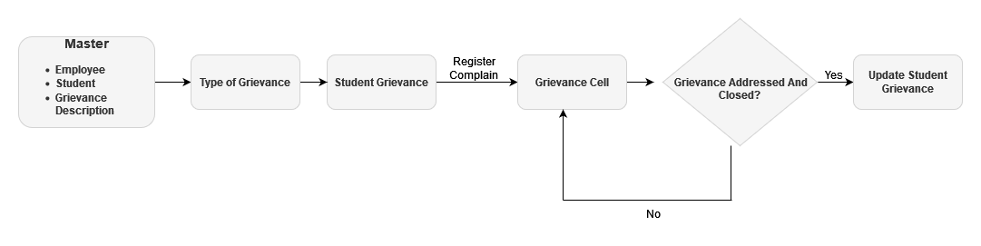

# Process Flow Description

**Grievance Description**

This is one of the master screen for grievances , where grievances are described

**Type of Grievance**

This screen is where grievance type is defined and stored. Also employee can also be assigned to each type of grievance . The employees assigned will be responsible for handling that specific type of grievances

**Student Grievance**

Student Grievance is the screen where students submits there grievance regarding an issue encountered

**Grievance Cell**

In this screen , grievances submitted by the students is stored. Grievance cell can see the issues raised by the students and check on its progress and current status of the issue.

# List of Screen and their descriptions

The following tables lists the pages used in Academics module :

|  |  |  |
| --- | --- | --- |
| **Sl no** | **Screen Name** | **Description** |
|  | Employee | This screen contains basic information regarding a employee working for the company. |
|  | Student | The Student document will hold all the data related to the students. |
|  | Grievance Description | This master screen is where grievances are described and stored |
|  | Type of Grievance | This screen is where grievance type is defined and stored. Also employee can also be assigned to each type of grievance . The employees assigned will be responsible for handling that specific type of grievances |
|  | Student Grievance | In this screen a student can register a complain |
|  | Grievance Cell | In this screen issues and grievance submitted type student is stored, also this page is used to track and check the status of the grievance |

# Grievance

## Grievance Description

**General Description**

The following table describes overall information about this screen:

|  |  |
| --- | --- |
| **Description** | This master screen is where grievances are described and stored |
| **Navigation** | None |
| **Pre-requisites** | None |
| **Existing Screen Name** | None |
| **New Screen Name** | Grievance Description |

**Screenshot**



Figure 1 :Grievance Description

**Field List**

The following table describes the UI fields present in this screen :

|  |  |  |  |  |  |  |
| --- | --- | --- | --- | --- | --- | --- |
| **ID** | **Field Name** | **Field Type** | **Mandatory** | **Validation/Action** | **Remarks** | **R = Rename ,**  **N = New ,**  **D =Delete** |
| 1 | Type of Grievance | Text | Yes |  |  |  |
| 2 | Description of Grievance | Text |  |  |  |  |

**Users: Roles and Permissions**

The following table describes the users and their roles and permissions for the screens :

|  |  |  |  |  |  |  |  |  |
| --- | --- | --- | --- | --- | --- | --- | --- | --- |
| **ID** | **Role** | **Read** | **Write** | **Create** | **Delete** | **Submit** | **Cancel** | **Amend** |
| 1 | Grievance Manager | Yes | Yes | Yes | Yes | NA | NA | NA |
| 2 | Grievance User | Yes | Yes | No | No | NA | NA | NA |
| 3 | Student | Yes | No | No | No | NA | NA | NA |

## Type of Grievance

**General Description**

The following table describes overall information about this screen:

|  |  |
| --- | --- |
| **Description** | This screen is where grievance type is defined and stored. Also employee can also be assigned to each type of grievance . The employees assigned will be responsible for handling that specific type of grievances |
| **Navigation** | None |
| **Pre-requisites** | 1. Employee 2. Grievance Description |
| **Existing Screen Name** | None |
| **New Screen Name** | Type of Grievance |

**Screenshot**

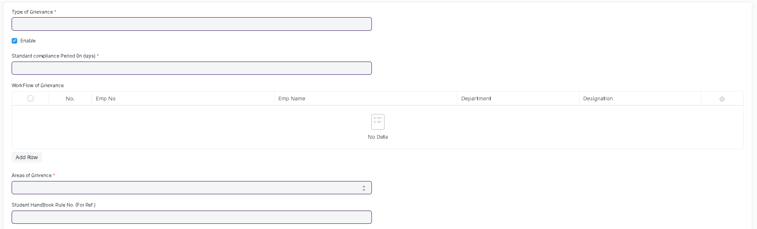

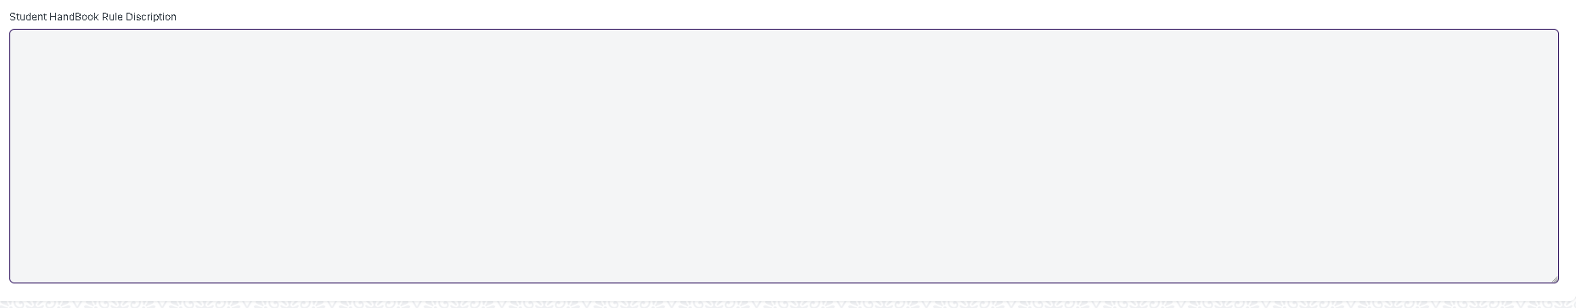

Figure 2:Type of Grievance

**Field List**

The following table describes the UI fields present in this screen :

|  |  |  |  |  |  |  |
| --- | --- | --- | --- | --- | --- | --- |
| **ID** | **Field Name** | **Field Type** | **Mandatory** | **Validation/Action** | **Remarks** | **R = Rename ,**  **N = New ,**  **D =Delete** |
| 1 | Type of Grievance | Link | Yes | Links to grievance description |  |  |
| 2 | Enable | Checkbox |  | If checked then this type of grievance will be available for student grievance and further screens |  |  |
| 3 | Description of Grievance | Text | Yes | A read-only field that is filled as per the type of grievance selected |  |  |
| 4 | Standard compliance Period | Number | Yes |  |  |  |
| 5 | **Workflow of Grievance** | Table |  | In this table ,employee can be assigned to that certain grievance | This table is described below |  |
| 6 | Areas of Grievance | Dropdown |  | Used to determine the grievance category. | Education  Employment  Academics  Ragging  Accommodation  Non -Teaching Activities  Transportation  Health  Fooding  social awareness  seminars  workshops  Violence Against Women  The Sexual Harassment of Women at Workplace  Exam  Class Room  Cyber security |  |
| 7 | Student Handbook Rule No. | Text |  |  |  |  |
| 8 | Student Handbook Rule Description | Text Area |  |  |  |  |
| **ID** | **Field Name** | **Field Type** | **Mandatory** | **Validation/Action** | **Remarks** | **R = Rename ,**  **N = New ,**  **D =Delete** |
| 1 | Emp No. | Link |  | Links to Employee master screen |  |  |
| 2 | Emp Name | Text |  | A read only field that will be filled as per employee number selected |  |  |
| 3 | Department | Text |  | A read only field that will be filled as per employee number selected |  |  |
| 4 | Designation | Text |  | A read only field that will be filled as per employee number selected |  |  |

**Users: Roles and Permissions**

The following table describes the users and their roles and permissions for the screens :

|  |  |  |  |  |  |  |  |  |
| --- | --- | --- | --- | --- | --- | --- | --- | --- |
| **ID** | **Role** | **Read** | **Write** | **Create** | **Delete** | **Submit** | **Cancel** | **Amend** |
| 1 | Grievance Manager | Yes | Yes | Yes | Yes | NA | NA | NA |
| 2 | Grievance User | Yes | Yes | No | No | NA | NA | NA |
| 3 | Student | Yes | No | No | No | NA | NA | NA |

## Student Grievance

**General Description**

The following table describes overall information about this screen:

|  |  |
| --- | --- |
| **Description** | In this screen a student can register a complain |
| **Navigation** | None |
| **Pre-requisites** | 1. Employee 2. Student 3. Type of Grievance |
| **Existing Screen Name** | None |
| **New Screen Name** | Student Grievance |

**Screenshot**

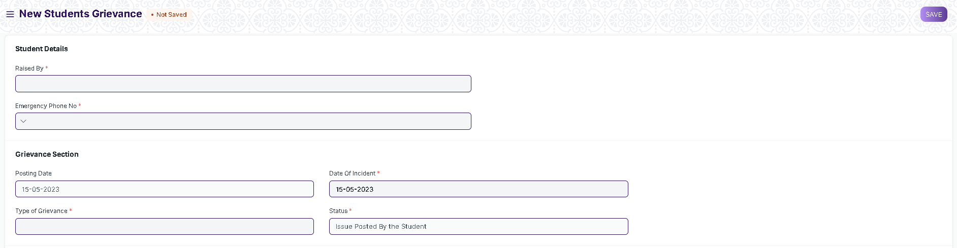

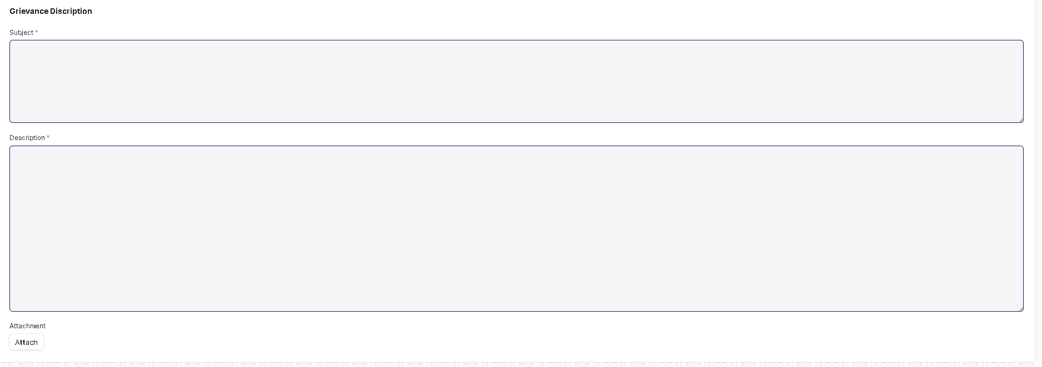

Figure 3:Student Grievance

**Field List**

The following table describes the UI fields present in this screen :

|  |  |  |  |  |  |  |
| --- | --- | --- | --- | --- | --- | --- |
| **ID** | **Field Name** | **Field Type** | **Mandatory** | **Validation/Action** | **Remarks** | **R = Rename ,**  **N = New ,**  **D =Delete** |
| 1 | Raised By | Link | Yes | Links to Student Screen |  |  |
| 2 | Student Name | Text |  | This is a read only and field and is filled as per student selected |  |  |
| 3 | Emergency Phone Number | Phone |  |  |  |  |
| 4 | Email Id | Text |  | This field is also a read only field and filled as per Student selected |  |  |
| 5 | Gender | Text | Yes | This field is also a read only field and filled as per Student selected |  |  |
| 6 | Posting Date | Date |  | A read-only field , its value is alloted as per current date |  |  |
| 7 | Date of Incident | Date | Yes |  |  |  |
| 8 | Type of Grievance | Link |  | Links to Type of Grievance |  |  |
| 9 | Status | Text |  | When a students fills it , the default value stays as “ Issue raised by student” , after action taken by grievance cell then the status field will be updated |  |  |
| 10 | Description of Grievance | Text |  | Read-only field , is filled as per type of grievance selected |  |  |
| 11 | Areas of Grievance | Text |  | Read-only field , is filled as per type of grievance selected |  |  |
| 12 | Subject | Text |  | Student can fill this field regarding the issue they faced |  |  |
| 13 | Description | Text Area |  |  |  |  |
| 14 | Resolution Date | Date |  | This field will be updated as per grievance cells action and when the particular issue is marked as resolved , that date will be filled in this field |  |  |
| 15 | Resolution Details | Text Area |  | In this field grievance cell can fill the field addressing student issue ,with the solution that they offered |  |  |
| 16 | Register Complain | Button |  | After saving and submitting the form this button will appear , when clicked this will redirect to grievance cell screen with some of the necessary details filled |  |  |
| 17 | Attach | Button |  | In this field the student can attach a document regarding their grievance |  |  |

**Users: Roles and Permissions**

The following table describes the users and their roles and permissions for the screens :

|  |  |  |  |  |  |  |  |  |
| --- | --- | --- | --- | --- | --- | --- | --- | --- |
| **ID** | **Role** | **Read** | **Write** | **Create** | **Delete** | **Submit** | **Cancel** | **Amend** |
| 1 | Grievance Manager | Yes | Yes | Yes | Yes | Yes | Yes | Yes |
| 2 | Grievance User | Yes | Yes | Yes | No | Yes | Yes | Yes |
| 3 | Student | Yes | No | No | No | Yes | No | No |

## Grievance Cell

**General Description**

The following table describes overall information about this screen:

|  |  |
| --- | --- |
| **Description** | In this screen issues and grievance submitted type student is stored, also this page is used to track and check the status of the grievance |
| **Navigation** | None |
| **Pre-requisites** | 1. Employee 2. Student 3. Student Grievance |
| **Existing Screen Name** | None |
| **New Screen Name** | Grievance Cell |

**Screenshot**

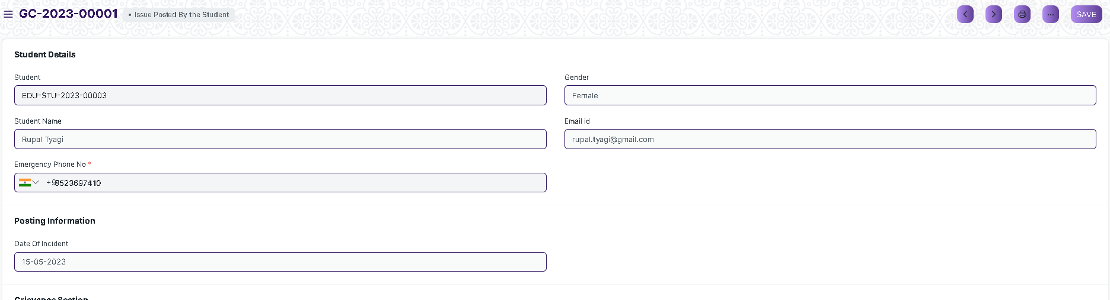

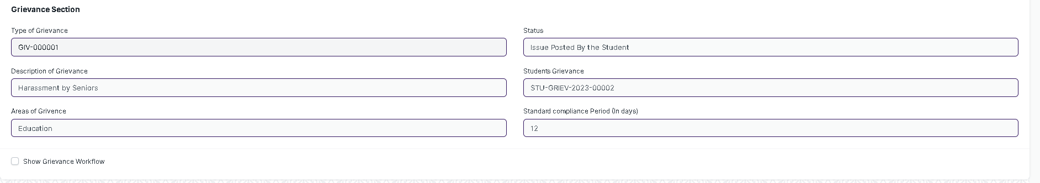

Figure 4:Grievance Cell

**Field List**

The following table describes the UI fields present in this screen :

|  |  |  |  |  |  |  |
| --- | --- | --- | --- | --- | --- | --- |
| **ID** | **Field Name** | **Field Type** | **Mandatory** | **Validation/Action** | **Remarks** | **R = Rename ,**  **N = New ,**  **D =Delete** |
| 1 | Raised By | Link | Yes | Links to Student Screen |  |  |
| 2 | Student Name | Text |  | This is a read only and field and is filled as per student selected |  |  |
| 3 | Emergency Phone Number | Phone |  |  |  |  |
| 4 | Email Id | Text |  | This field is also a read only field and filled as per Student selected |  |  |
| 5 | Gender | Text | Yes | This field is also a read only field and filled as per Student selected |  |  |
| 6 | Posting Date | Date |  | A read-only field , its value is alloted as per current date |  |  |
| 8 | Type of Grievance | Link |  | Links to Type of Grievance |  |  |
| 9 | Status | Text |  | When a students fills it , the default value stays as “ Issue raised by student” , after action taken by grievance cell then the status field will be updated |  |  |
| 10 | Description of Grievance | Text |  | Read-only field , is filled as per type of grievance selected |  |  |
| 11 | Areas of Grievance | Text |  | Read-only field , is filled as per type of grievance selected |  |  |
| 12 | Standard Compliance Period | Number |  | Read-only field , is filled as per type of grievance selected |  |  |
| 13 | Show Grievance Workflow | Checkbox |  | When checked it shows the table - workflow of grievance , which contains employees assigned to the grievance .  And Grievance Status which holds the current progress regarding the status |  |  |
| 14 | **Workflow of Grievance** | Table |  | In this table ,employees assigned to that certain grievance are visible | This table is described below |  |
| 15 | **Grievance Status** | Table |  | This table tracks the ongoing status of the grievance | This table is described below |  |
| **ID** | **Field Name** | **Field Type** | **Mandatory** | **Validation/Action** | **Remarks** | **R = Rename ,**  **N = New ,**  **D =Delete** |
| 1 | Emp No. | Link |  | Links to Employee master screen |  |  |
| 2 | Emp Name | Text |  | A read only field that will be filled as per employee number selected |  |  |
| 3 | Department | Text |  | A read only field that will be filled as per employee number selected |  |  |
| 4 | Designation | Text |  | A read only field that will be filled as per employee number selected |  |  |
| **ID** | **Field Name** | **Field Type** | **Mandatory** | **Validation/Action** | **Remarks** | **R = Rename ,**  **N = New ,**  **D =Delete** |
| 1 | Emp No. | Link |  | Links to Employee master screen |  |  |
| 2 | Emp Name | Text |  | A read only field that will be filled as per employee number selected |  |  |
| 3 | Date of Posting | Date |  |  |  |  |
| 4 | Decision | Dropdown |  | Contains option regarding the status of the grievance | Issue Posted By Student Issue Received By Grievance Cell Issue Forwarded to Competent Authority Issue pending from Competent Authority Issue Closed |  |
| 5 | File Status | Dropdown |  | Contains options regarding if the file is ongoing or not | Opened  Closed |  |
| 6 | Remarks | Text |  | This field is used to write a remark regarding the solution of the grievance |  |  |

**Users: Roles and Permissions**

The following table describes the users and their roles and permissions for the screens :

|  |  |  |  |  |  |  |  |  |
| --- | --- | --- | --- | --- | --- | --- | --- | --- |
| **ID** | **Role** | **Read** | **Write** | **Create** | **Delete** | **Submit** | **Cancel** | **Amend** |
| 1 | Grievance Manager | Yes | Yes | Yes | Yes | Yes | Yes | Yes |
| 2 | Grievance User | Yes | Yes | Yes | No | Yes | Yes | Yes |
| 3 | Student | Yes | No | No | No | Yes | No | No |